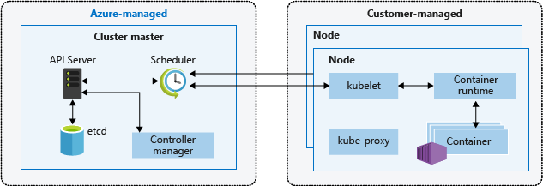

<https://docs.microsoft.com/en-us/azure/aks/concepts-clusters-workloads>

Minikube (Local K8s cluster)

<https://kubernetes.io/docs/tasks/tools/install-minikube/>